**Basic C programming Question for compiler**

**1. Character Counter**

**Question:** Write a program to count the number of occurrences of a specific character in a given string.  
**Input:**

* Enter a string: hello world
* Enter a character to count: l

**code:**

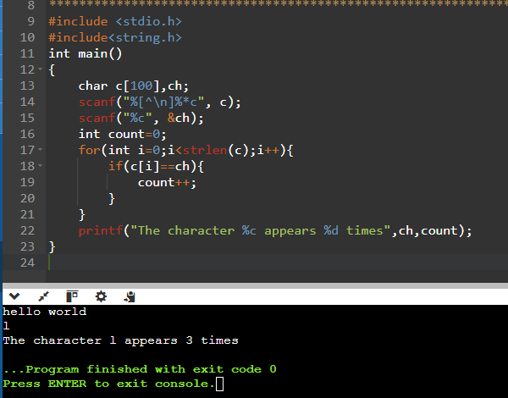

**2. Token Separator**

**Question:** Write a program to split a string into tokens based on a delimiter (e.g., space).  
**Input:**

* Enter a string: Compiler Design is Fun
* Enter the delimiter: (space)

**Output:**

* Token 1: Compiler
* Token 2: Design
* Token 3: is
* Token 4: Fun

**code:**

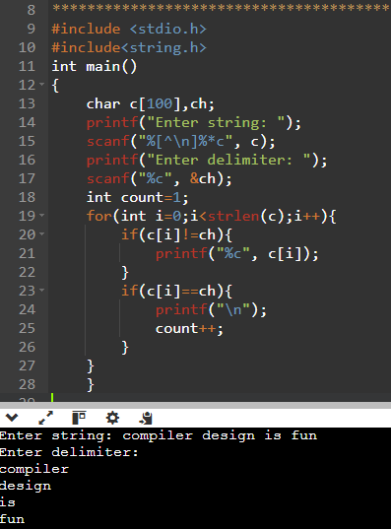

**3. Keyword Identifier**

**Question:** Write a program to check if a given word is a C keyword or not.  
**Input:**

* Enter a word: for

**Output:**

* The word 'for' is a C keyword.

**code:**

**4. Palindrome Checker**

**Question:** Write a program to check if a string is a palindrome.  
**Input:**

* Enter a string: level

**Output:**

* The string is a palindrome.

**Code:**

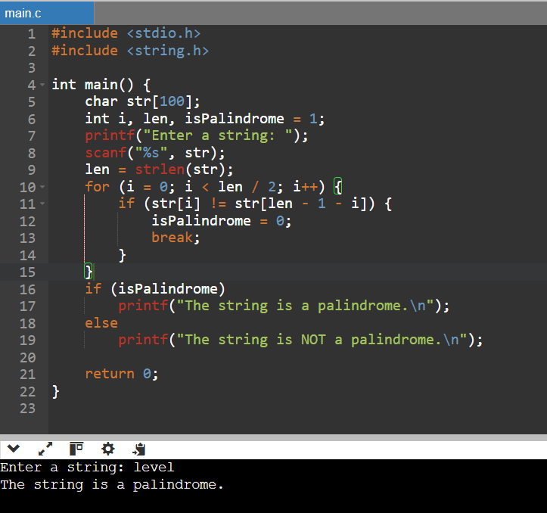

**5. Arithmetic Expression Evaluator**

**Question:** Write a program to evaluate a simple arithmetic expression (e.g., 5 + 3).  
**Input:**

* Enter an arithmetic expression: 5 + 3

**Output:**

* Result: 8

**Code:**

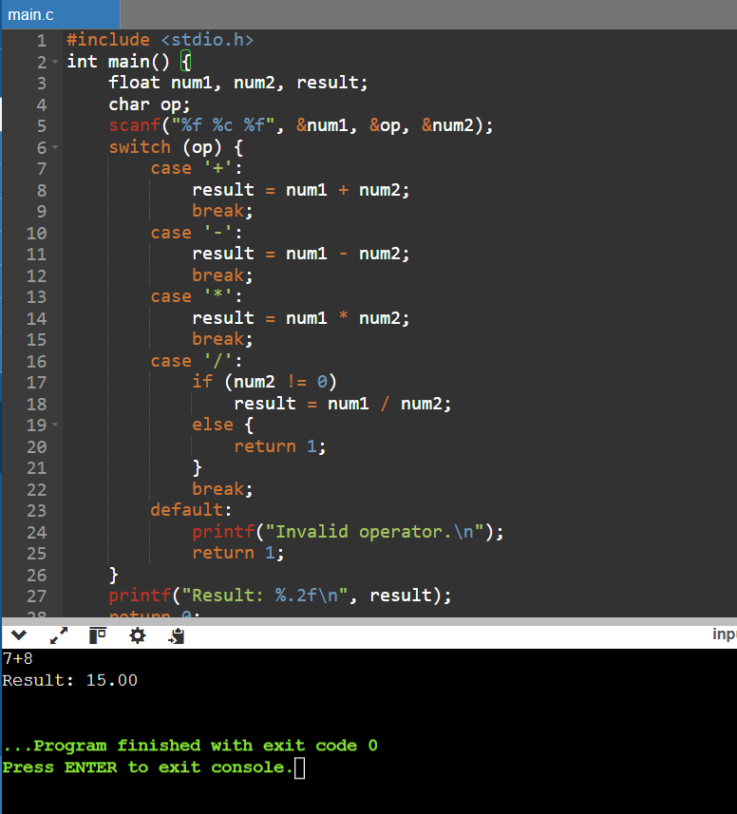

**6. ASCII Value Finder**

**Question:** Write a program to print the ASCII value of a character.  
**Input:**

* Enter a character: A

**Output:**

* ASCII value of 'A': 65

**code:**

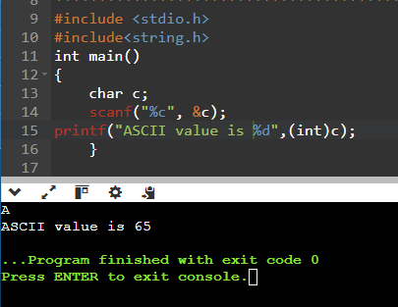

**7. Symbol Table Generator**

**Question:** Write a program to create a symbol table with variable names and data types given as input.  
**Input:**

* Enter the number of variables: 2
* Enter variable name and type: x int, y float

**Output:**

| **Variable Name** | **Data Type** |
| --- | --- |
| x | int |
| y | float |

**8. Odd-Even Identifier**

**Question:** Write a program to identify whether a given integer is odd or even.  
**Input:**

* Enter an integer: 7

**Output:**

* 7 is odd.

**code**:

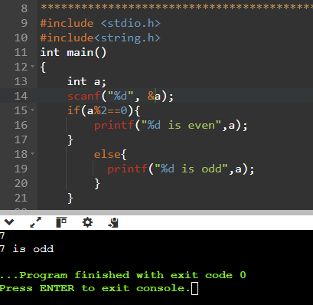

**9. Prime Number Checker**

**Question:** Write a program to check if a number is prime.  
**Input:**

* Enter a number: 13

**Output:**

* 13 is a prime number.

**code:**

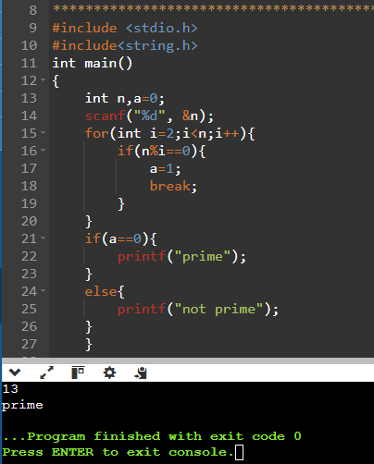

**10. Fibonacci Series Generator**

**Question:** Write a program to generate the first n numbers in the Fibonacci series.  
**Input:**

* Enter the value of n: 5

**Output:**

* Fibonacci Series: 0, 1, 1, 2, 3

**code:**

